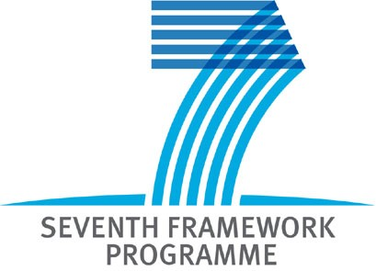 |  | 
“EU-12 partnering EU-15”
Brokerage Event Prague, 28-29 January 2008

Guidelines for 5 min. presentations

International Partnering Meeting
Find partners for your FP7 projects
European collaboration for R&D and Innovation in the NMP

Only the presentations respecting the following guidelines will be accepted:
• Language: English
• Duration: max. 5 minutes
• Number of slides: max. 5
• Number of words per slide: max. 40
• Format: MS-Powerpoint (ppt)
• Compress all pictures to web resolution - 96 dots per inch (dpi)
• Contents requirements for coordinators:
1. Complete contact information of the presenter/organization
2. Previous experience within FP5 / FP6 / national research projects
3. Current proposal title, main objectives and key deliverables
4. First choice topic according to topics list (next page)
5. Actual Consortium and complementary competences and skills sought to
complete the consortium

• Contents requirements for partners:
1. Complete contact information of the presenter/organization
2. Previous experience within FP5 and FP6
3. First choice topic according to topics list (next page)
4. Key competences and skills within the organization
• Presentation submission:
Send your presentation to the following addresses before 21.1.2008:
prokop@tc.cz; dvorakovaz@tc.cz

List of Topics - Monday, 28th of January 2008

NMP-2008-1.1-1:  Converging sciences and technologies  (nano, bio, info and/or cogni). | Small or medium-scale focused research projects
NMP-2008-1.1-3:  Examining capacity building in nanobiotechnology. | Coordinating and support action
NMP-2008-1.2-2:  Nanotechnologies for water treatment  (in coordination with Theme ENVIROMENT) | Small or medium-scale focused research projects
NMP-2008-1.3-1  Validation, adaptation and/or development of risk assessment. | Collaborative projects targeted to SMEs.
NMP-2008-1.3-2  Impact of engineered nanoparticles on health and the environment | Small or medium-scale focused research projects
NMP-2008-2.3-1:  Advanced implants and bioactive materials for critical organs | Small or medium-scale focused research projects
NMP-2008-4.0-1:  Development of nanotechnology-based systems for diagnosis  and/or therapy for diabetes, musculo-skeletal or inflammatory diseases (in coordination with Theme HEALTH) | Large-scale integrating collaborative projects.

List of Topics - Tuesday, 29th of January 2008

NMP-2008-2.2-1:  Compound semiconductors for electronics and photonics | Large-scale integrating collaborative projects.
NMP-2008-2.2-2:  Nanostructured meta-materials | Small or medium-scale focused research projects
NMP-2008-2.1-1  Nanostructured membrane materiále. | Small or medium-scale focused research projects
NMP-2008-2.4-2  Radical advances in the processing of multifunctional films and tapes. | Small or medium-scale focused research projects
NMP-2008-2.6-1:  Novel materials for energy applications (Joint call with Energy). | Collaborative projects targeted to SMEs.

