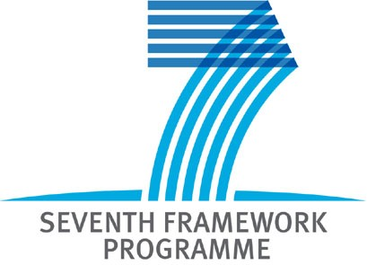 |  | 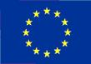
“EU-12 partnering EU-15”
Brokerage Event Prague, 28-29 January 2008

DRAFT AGENDA

Monday, 28th of January 2008

10:00 Registration and coffee

10:30 Opening and Address of Welcome
Vladimir Albrecht TC AS CR

10:50 Nanotechnology in FP7: New Challenges in the Framework of the 2nd NMP Calls
representatives of Unit G4, European Commission, Brussels (TBC)

11:40 Invited speakers
represenatives of leading research institutions and networks from EU15 (TBC)

12:50 Introduction to the parallel afternoon sessions
Alexandr Prokop, NCP NMP, TC AS CR
Thematic insight into the different parallel workshops and presentation of organizational issues relevant for successful running of the afternoon sessions.

13:00 Lunch

13:50 Afternoon parallel sessions with 5 minutes presentations of projects in preparation and of skills
The topics discussed at the partnering event are part of the second call for proposals in Theme 4.

NMP-2008-1.1-1:  Converging sciences and technologies (nano, bio, info and/or cogni). | Small or medium-scale focused research projects
NMP-2008-1.1-3:  Examining capacity building in nanobiotechnology. | Coordinating and support action
NMP-2008-1.2-2:  Nanotechnologies for water treatment  (in coordination with Theme ENVIROMENT) | Small or medium-scale focused research projects
NMP-2008-1.3-1:  Validation, adaptation and/or development of risk assessment. | Collaborative projects targeted to SMEs.
NMP-2008-1.3-2:  Impact of engineered nanoparticles on health and the environment | Small or medium-scale focused research projects
NMP-2008-2.3-1:  Advanced implants and bioactive materials for critical organs | Small or medium-scale focused research projects
NMP-2008-4.0-1:  Development of nanotechnology-based systems for diagnosis  and/or therapy for diabetes, musculo-skeletal or inflammatory diseases (in coordination with Theme HEALTH) | Large-scale integrating collaborative projects.

16:00 Networking and bilateral meetings
We offer conference rooms for project discussions

16:00 Workshop: „How to prepare a convincing FP7 proposal – short introduction into proposal writing“
(TBC)

17:30 End

Tuesday, 29th of January 2008

10:00 Registration and coffee

10:30 Opening and Address of Welcome
Alexandr Prokop TC AS CR

10:50 Materials in FP7: New Challenges in the Framework of the 2nd NMP Calls
represenatives of Unit G3, European Commission, Brussels (TBC)

11:40 Invited speakers
represenatives of leading research institutions and networks from EU15 (TBC)

12:50 Introduction to the parallel afternoon sessions
Alexandr Prokop, NCP NMP, TC AS CR
Thematic insight into the different parallel workshops and presentation of organizational issues relevant for successful running of the afternoon sessions.

13:00 Lunch

13:50 Afternoon parallel sessions with 5 minutes presentations of projects in preparation and of skills
The topics discussed at the partnering event are part of the second call for proposals in Theme 4.

NMP-2008-2.2-1:  Compound semiconductors for electronics and photonics | Large-scale integrating collaborative projects.
NMP-2008-2.2-2:  Nanostructured meta-materials | Small or medium-scale focused research projects
NMP-2008-2.1-1:  Nanostructured membrane materiále. | Small or medium-scale focused research projects
NMP-2008-2.4-2:  Radical advances in the processing of multifunctional films and tapes. | Small or medium-scale focused research projects
NMP-2008-2.6-1:  Novel materials for energy applications (Joint call with Energy). | Collaborative projects targeted to SMEs.

16:00 Networking and bilateral meetings
We offer conference rooms for project discussions

17:30 End

Should you have any questions regarding the program do not hesitate to contact:
Alexandr Prokop
NCP Czech Republic
Technology Centre AS CR
Rozvojova 135, 165 02 Prague 6, Czech Republic
phone: +420 234 006 109, mobile: +420 724 829 447
fax: +420 220 922 698
e-mail: prokop@tc.cz ; web page: http://www.tc.cz

