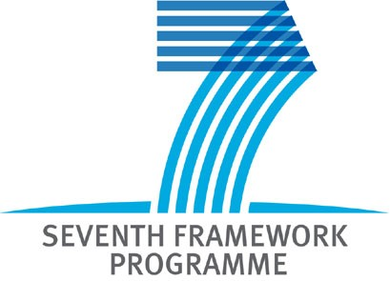 |  | 
“EU-12 partnering EU-15”
Brokerage Event Prague, 28-29 January 2008

venue

CZECH UNIVERSITY OF LIFE SCIENCES PRAGUE
STUDY AND INFORMATION CENTRE
KAMÝCKÁ 129, 165 21, PRAGUE 6 - SUCHDOL

organized by

Technology Centre of the Academy of Sciences CR
with support from European Commission

Aim:
to strengthen the participation of partners from the New Member States in the FP7 projects.

FP7 Collaborations
in Nanotechnology and Material Sector

- find partners, mainly from new EU states to your
collaborative project
- become a partner in presented project
- benefit from partnering one-to-one meetings
with participation of EC representatives and leading
research institutions from EU15 as well as EU12

REGISTRATION
There is no registration fee for participants.
Access to the online registration and partnering tool is available at http://EU12partneringEU15.ircnet.lu
All participants who wish to attend the seminar are kindly requested to register before 21st of January 2008.
The workshop language is English.
CONTACT
Alexandr Prokop, NCP Czech Republic
Technology Centre AS CR
Rozvojova 135, 165 02 Prague 6, Czech Republic
phone: +420 234 006 109, mobile: +420 724 829 447
fax: +420 220 922 698
e-mail: prokop@tc.cz
http://www.tc.cz

The event will be focused on topics:
Day 1 – 28th January 2008
NMP-2008-1.1-1:  Converging sciences and technologies (nano, bio, info and/or cogni). | Small or medium-scale focused research projects
NMP-2008-1.1-3:  Examining capacity building in nanobiotechnology. | Coordinating and support action
NMP-2008-1.2-2:  Nanotechnologies for water treatment (in coordination with Theme ENVIROMENT) | Small or medium-scale focused research projects
NMP-2008-1.3-1  Validation, adaptation and/or development of risk assessment. | Collaborative projects targeted to SMEs.
NMP-2008-1.3-2  Impact of engineered nanoparticles on health and the environment | Small or medium-scale focused research projects
NMP-2008-2.3-1:  Advanced implants and bioactive materials for critical organs | Small or medium-scale focused research projects
NMP-2008-4.0-1:  Development of nanotechnology-based systems for diagnosis  and/or therapy for diabetes, musculo-skeletal or inflammatory diseases (in coordination with Theme HEALTH) | Large-scale integrating collaborative projects.
Day 2 – 29th January 2008
NMP-2008-2.2-1:  Compound semiconductors for electronics and photonics | Large-scale integrating collaborative projects.
NMP-2008-2.2-2:  Nanostructured meta-materials | Small or medium-scale focused research projects
NMP-2008-2.1-1  Nanostructured membrane materiále. | Small or medium-scale focused research projects
NMP-2008-2.4-2  Radical advances in the processing of multifunctional films and tapes. | Small or medium-scale focused research projects
NMP-2008-2.6-1:  Novel materials for energy applications (Joint call with Energy). | Collaborative projects targeted to SMEs.
Event. doplním později na základě konzultace

Twin event: EU12 partnering EU15,
Wroclaw, 1st February 2008
FP7 Collaboration in Nanomaterials and technologies

These topics are published in Work Programme 2008 NMP (EC C(2007)5765 of 29 Nov.2007)

